Reporting & EOM Payroll Master Checklist

# Month_____________________________________________________________

1. **Report new hires to the Office of the Attorney General of Texas**
2. **Verify Prior Month is Completed in TRS RE Portal**
3. **Complete Child Nutrition Worksheet or obtain from Cafeteria Manager**
4. **Import Actual Days and Hours worked from your district’s timekeeping system**
5. **Prepare TRS Reports**
6. **Submit Employee Data (ED)**
7. **Submit Regular Payroll (PR)**
8. **Submit Employment After Retirement (ER)**
9. **Run the TRS On-Behalf Payment Report and interface**

**_____**10**. For districts with a Payroll Clearing Account at the Bank, transfer RP amounts (Stat Min, Public Education Employer Contrib, Child Nutrition amounts for TRS 3 & 489)**

**_____**11**. Submit TexNet online**

**______**12. **Post the TexNet Wire Transfer**

**______**13. **Interface your TRS 3, TRS 489, TRS 373 (Stat Min), and Public Education Employer Contribution**

**_____**14. **Run the Payroll Accrual Variance Extract Utility and correct as needed.**

**_____**15. **If applicable, run the 941 Quarterly Tax Report**

**_____**16**. If applicable, run the TWC Wage List for the Texas Workforce Commission**

**_____17. Run Unique ID’s and make sure any name changes are included in the upload**

**_____**18. **Reconcile Payroll Clearing Liability Accounts and Reconcile to the ledger at TRS**

_____ **1. Report new hires to the Office of the Attorney General of Texas. From Human Resources > Reports > HR Reports > Personnel Reports > New Hire Report**

The report lists employees whose employment dates fall between the user-provided beginning and ending dates. The **From Employment Date** is required. When the user clicks **Exception**, all employees whose information is incomplete and could not be included in the file are displayed (e.g., part of address missing). The file that is created by this report can be uploaded to the Office of the Attorney General of Texas. For additional information, go to the Office of the Attorney General of Texas website at <https://portal.cs.oag.state.tx.us/wps/portal/NewHiresReportingMethods>.

_____ **2.**  **Verify prior month is “Completed” in TRS RE Portal.**

_____ **3. Complete the Monthly Child Nutrition Worksheet** (TRS Form 154) if not completed by the Cafeteria Director. The form is available on our website. Complete the worksheet and Save in the Child Nutrition folder of the monthly payroll folder. The salary figure at the bottom of the worksheet will be used when extracting the Regular Payroll (RP).

_____ **4. Import the actual days and hours worked from your districts timekeeping system. If you use timekeeper, complete the following.** From the TimeKeeper file, select the Calendar Month Summary tab. Select the month and year in cell A2.

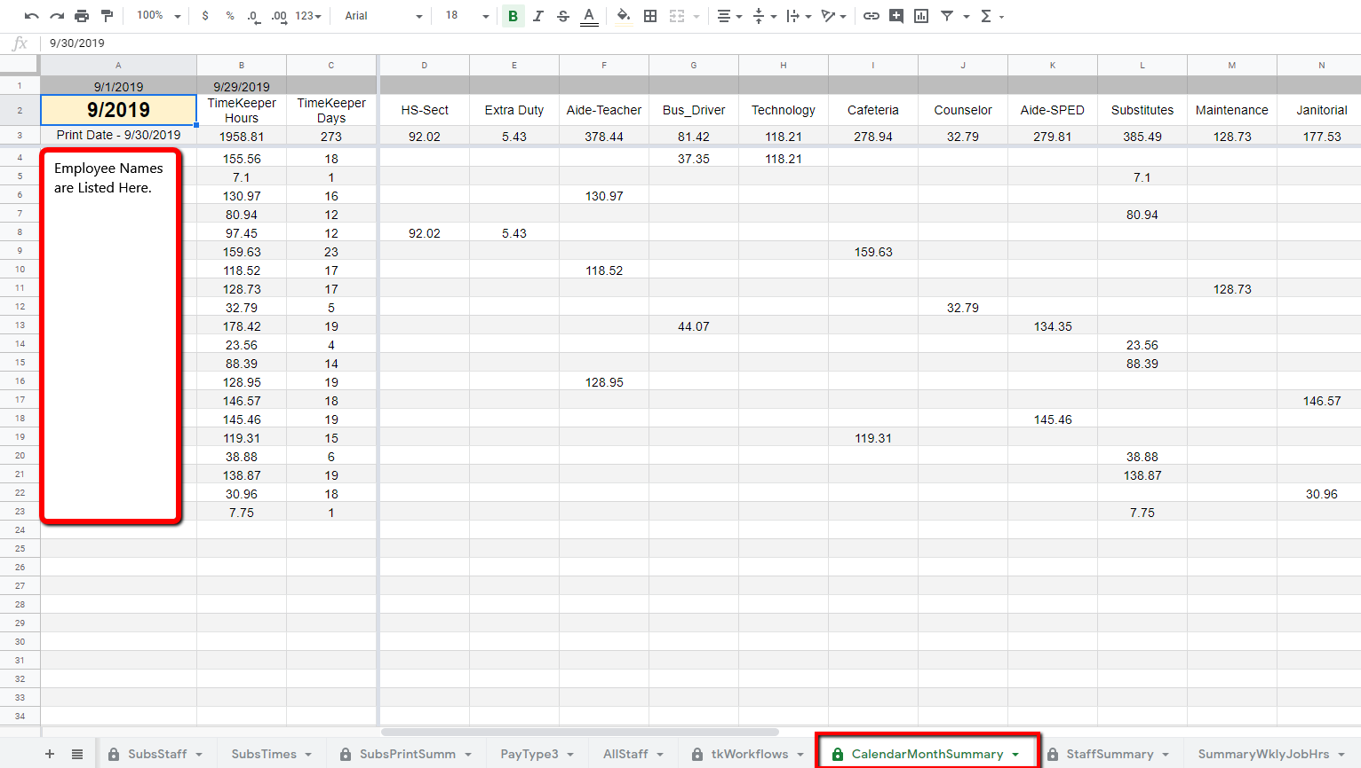

Then select Scripts. Choose the script for Create Actual Hours File. A browser pop up will confirm when the script has completed and placed the export file in the Google Drive Ascender transmittals folder. The file is named (ActHrsWrked6.txt) exactly as required for Ascender import.

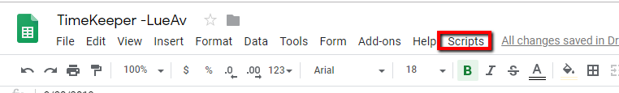

A file will automatically be saved in the same folder your timetm.txt and timelev.txt files are saved. Then go into **Ascender >Payroll >Utilities >Import Actual Hours Import**, and browse to find the file you saved from TimeKeeper and execute.

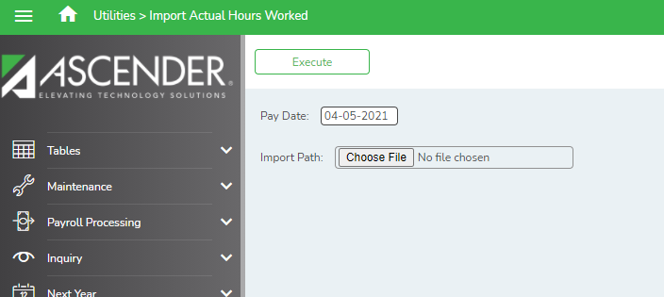

**_____5. Prepare TRS Submission and make corrections as needed. Payroll > Payroll Processing > TRS Processing.** Work will be completed working across the tabs from left to right. If a tab does not apply, you may skip it.

1. 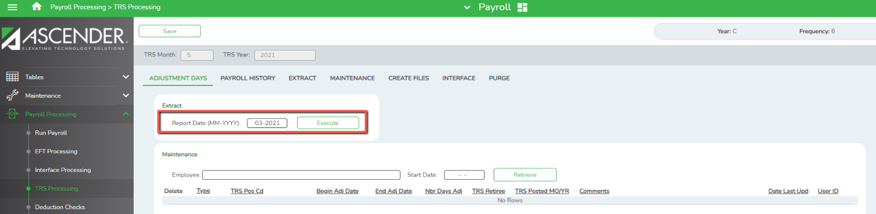**Adjustment Days tab –** used to add, edit or delete adjustment days in the current month. Extract for the month ifemployees were docked days and those days should be docked from the available days pulled from the TR Calendar.

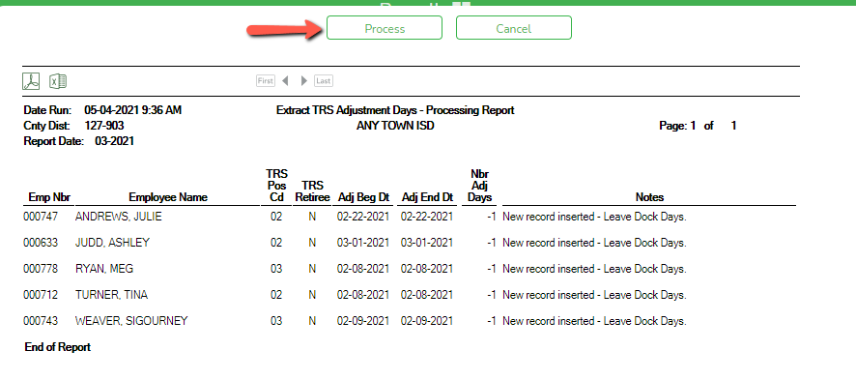If an employee was docked days during the pay period, you will see a preview report indicating the number of days that will be subtracted from the available days on the RP. Select Process to continue.

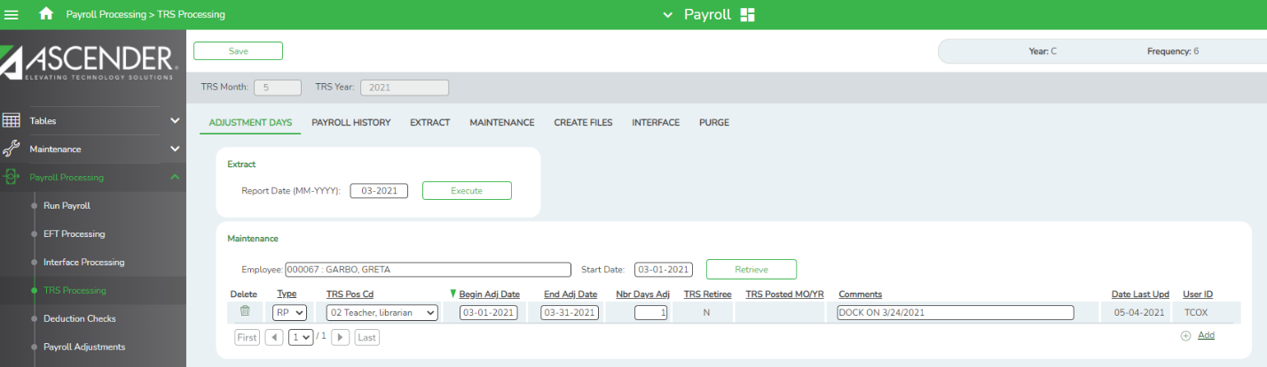Alternatively, you may add or subtract days from individual employees under the Maintenance section. Retrieve the employee desired. Check the spyglass beside the RP and manually change the number of days worked. Save any changes.

1. **Payroll History tab –** used to correct information entered into payroll incorrectly before we apply Stat Min and Public Education Employer Contribution. Below is an example:

If we paid Greta Garbo for One Act Play and should have made it subject to Stat Min (Expensed to 373) but forgot to check that box or set it up in our table incorrectly, we can correct it now. Retrieve the TRS Month and Year and the employee. If the Extra Duty was paid on the Pay Info tab and our table was wrong, in the Extra Duty section, find the One Act Play Extra Duty Code. In our example, the Expense 373 box is unselected. We believe it is subject to Stat Min and should have had the Expense 373 box checked. We can check it now and save so Stat Min calculations are done correctly.

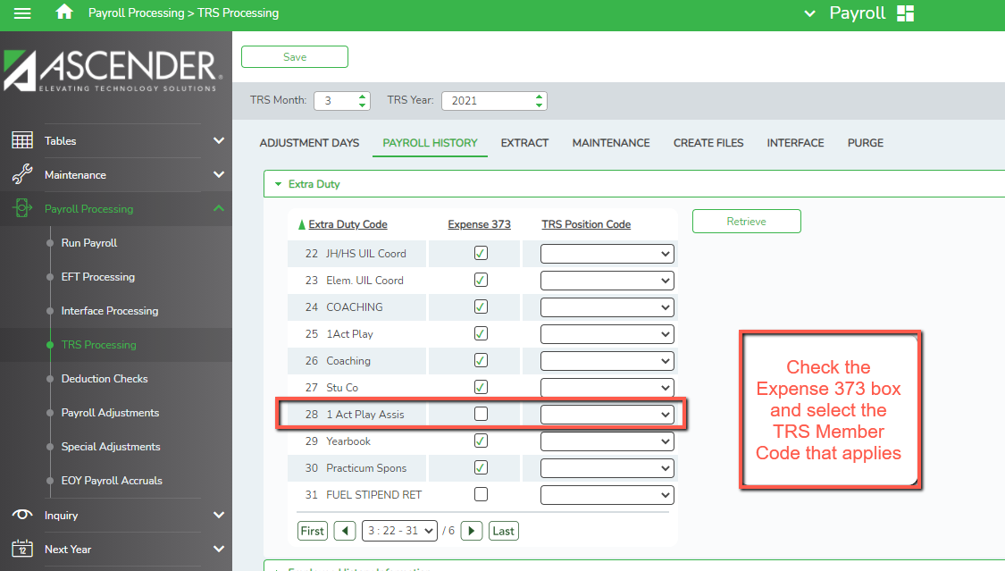

If the Extra Duty was paid on the Hours Pay Transmittals screen, make the correction under the Employee History Information section. In the example below, we selected the Expense 373 box on the Hours Pay Transmittals screen, but have now determined that this work is occasional and sporadic and therefore not subject to Stat Min. To reduce the Stat Min contribution, we can now correct that selection here. Save the changes.

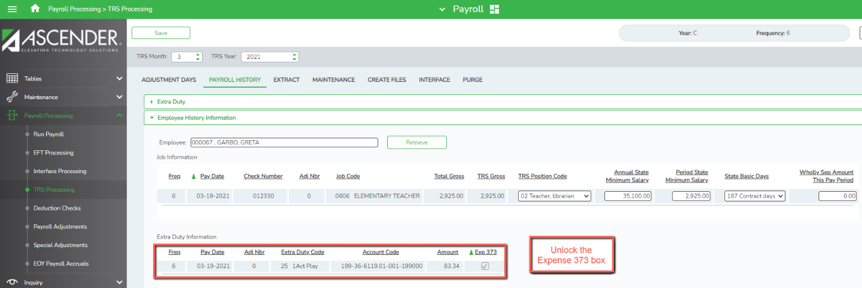

1. **Extract tab -** used to extract all data for the TRS submission at one time.

* Enter the **Report Date** (MMYYYY).
* Select the Extract Option desired
  + 1st time select **Delete all existing records and insert new records**.
  + All other times select **Insert new records or Delete all existing and insert new records** as desired.
* Check the **Pay Frequencies** applicable.
* Select the box in front of the **Employee Demographic (ED 20) Extract** to extract demographic records for any new employees who began working during the date range indicated in the Contract and Position box to the right.
* Select the **Contract and Position (ED40) Extract** box to extract contract and positions for the time period indicated in the date range. Enter a date range desired. Normally we pick up those who started in the month so it will be the first through the last day of the month.

**Note 1: In September use the first day 10 month employees come to work in August.**

**Note 2: If an employee worked a few days in the prior month, you may need to back the from date up to include that start date so the new employee will be pulled.**

* Select the **Regular Payroll (RP20) Extract** box to extract Payroll records.
  + The **Maximum Days Worked** should equal the Monday’s through Fridays in the month, regardless of whether it was a work day.
  + The **Maximum Hours Worked** should equal the Max Days X 8 hours.
  + Choose a **Default Zero Days Reason** that will be applied to any employee who shows they worked zero days, but still received pay. Most commonly it is because they have accrued pay, though other reasons can apply.
  + Enter the **Child Nutrition Salary and account code(s) for the TRS 3 & 489**. Enter the salary listed on line III at the bottom of the Child Nutrition Worksheet and Ascender12 will apply the correct percentages to each contribution. The Grant Code and Expense Account Code shown below are examples. We recommend a Grant Code not being used by other federal funds. If you need to include RP 25s to report Child Nutrition from the previous month you may add that here.

**Note: TRS will still allow you to report the prior month’s worksheet totals as the Current Month Salary. This option is provided for a district who chose to report the Current month and need this to report August and September together**.

However, this is not necessary. It will simply be a matter of preference.

* Select the **Employment After Retirement (ER20) Extract** box to extract Retiree data.
  + **Maximum Days** **Worked** will be the number of Mondays through Fridays in the month, divided by 2. If the number of Monday’s through Fridays is an odd number, divide by 2 and round up. In our example for October, there are 23 possible days in the month. Divide by 2 to get 11.5. Round up to 12.
  + **Maximum Hours Worked** should be the Total Monday’s through Fridays in the month multiplied by 4 hours.
  + Choose a **Default Zero Days Reason** that will be applied to any employee who shows they worked zero days, but still received pay. Most commonly it is because they have accrued pay, though other reasons can apply.
* Select the Adjustment Days box only if you entered data on the Adjustment Days tab that should be used to create RP 25s or ER27s.
* 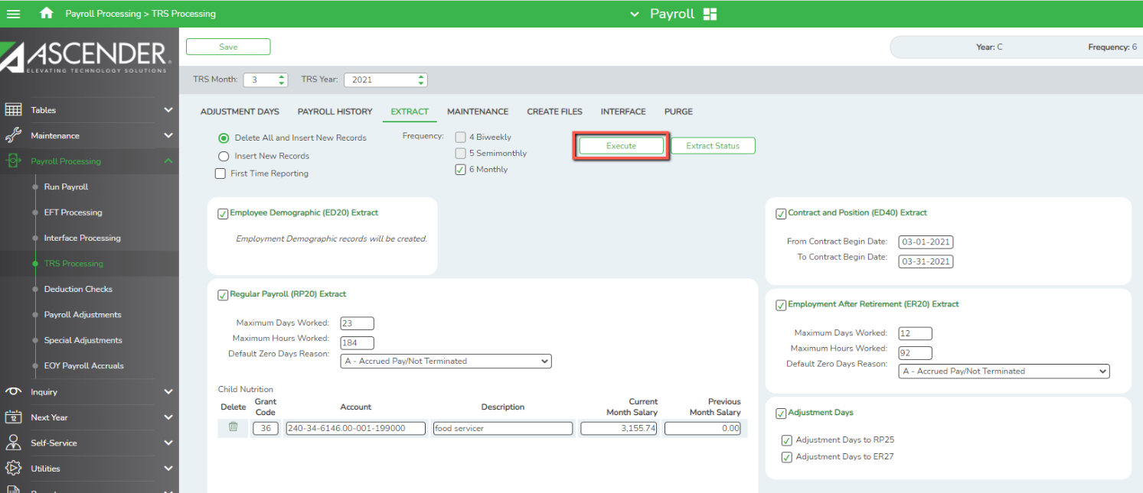Once all criteria have been selected, click **Execute**.

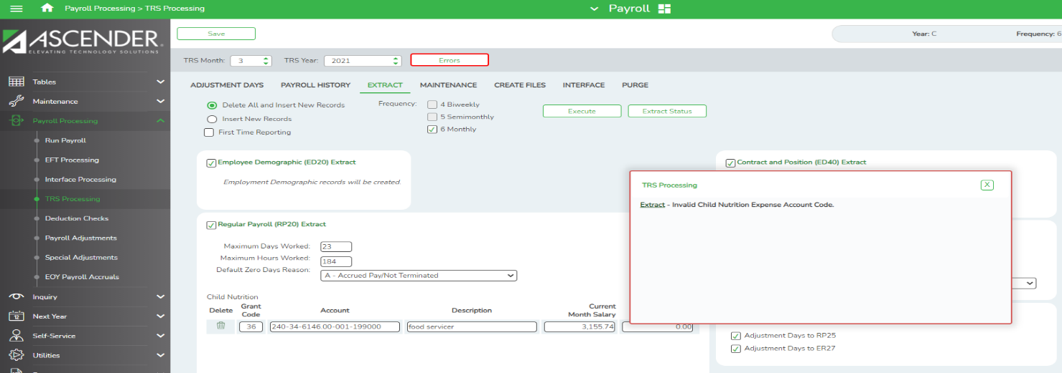**Note: If errors are present, a box will appear telling you what the errors are. You must correct before the Extract will complete.**

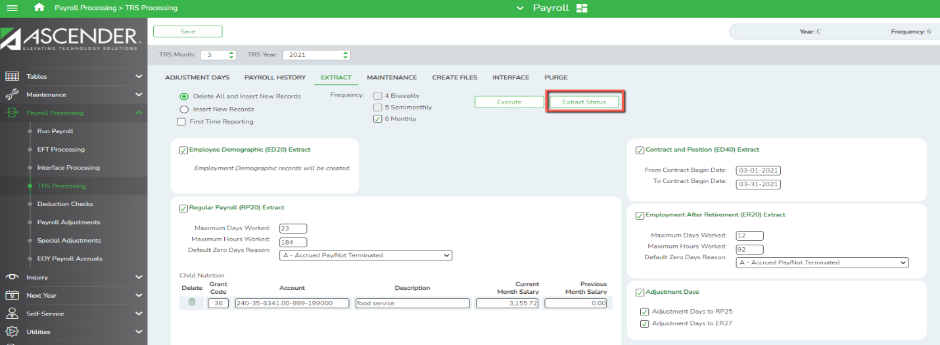Click the Extract Status button to see your Extract Reports.

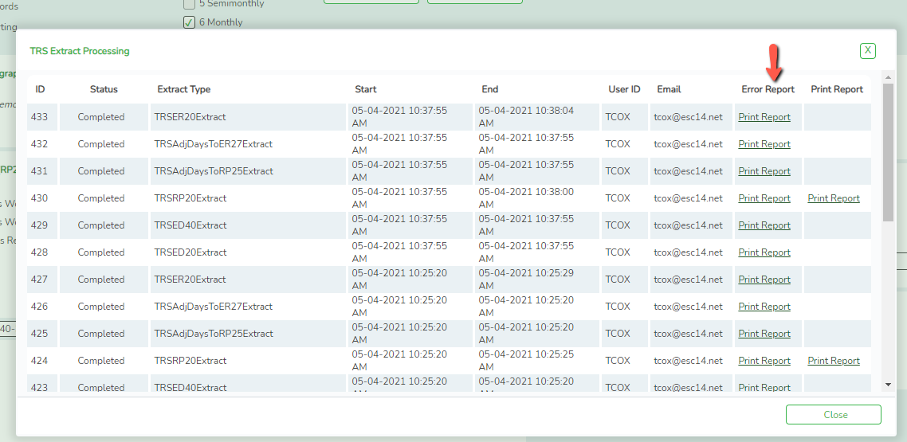Click the link to each Error Report to see if errors were encountered. Sample Error listings are shown below.

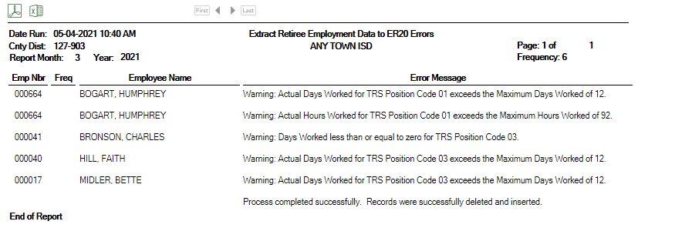

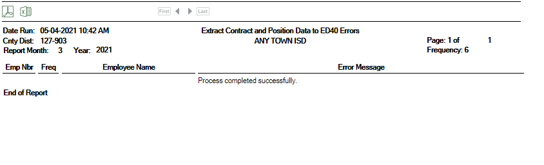

You can print the RP Report for review. (Or you may print from **Payroll >** **Reports > TRS Reports**.) It will include the following:

* Stat Min Report
* Stat Min General Journal
* 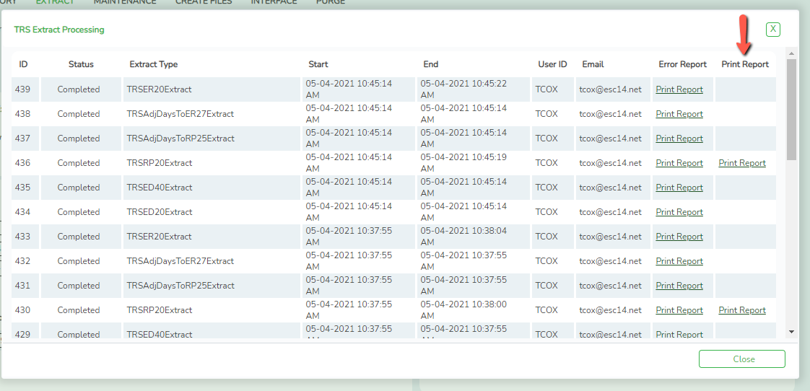Stat Min Account Distribution Journal

In addition to reviewing error listings, we recommend you review the following reports from **Payroll >** **Reports > TRS Reports:**

* HRS 7810 – TRS Statutory Minimum Report #373 (if not printed in step above)
* HRS 7815 - TRS Public Education Employer Contribution
* HRS 7820 – TRS 3 Report
* HRS 7825 – TRS 489 Report
* HRS 8900 - Employee Data (ED)
* HRS 8905 – Regular Payroll (RP)
* HRS 8910 – Employment After Retirement (ER)
* HRS 9865 – Payments for New Members
* HRS 9870 – Retiree Pension Surcharge
* HRS 9875 – Retiree TRS Care Surcharge

Review each report for accuracy. If changes need to be made, go back to **Payroll Processing > TRS Processing > Maintenance tab** to make corrections.

1. **Maintenance tab** – used to retrieve individual employees and make corrections.
   * Retrieve desired employee
   * 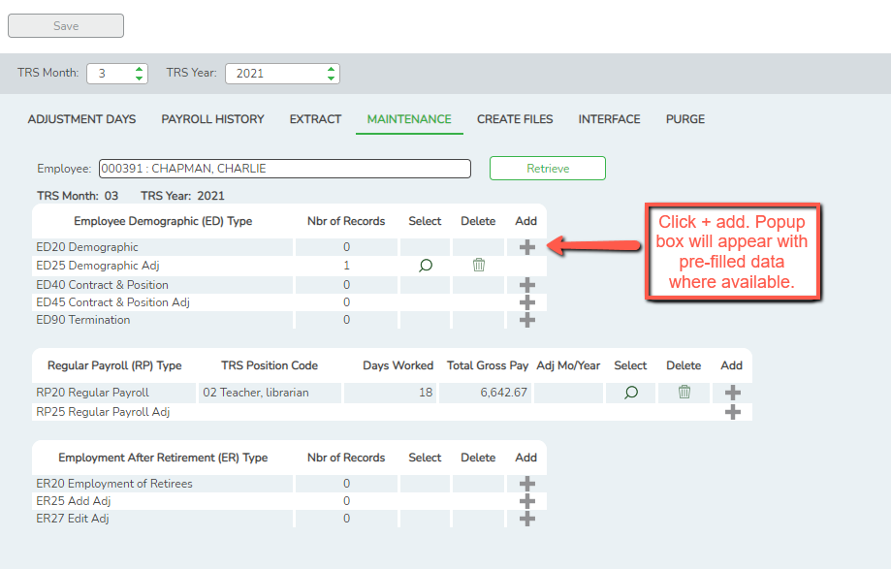Use the + button to add a record. Example of adding ED20 is shown below:

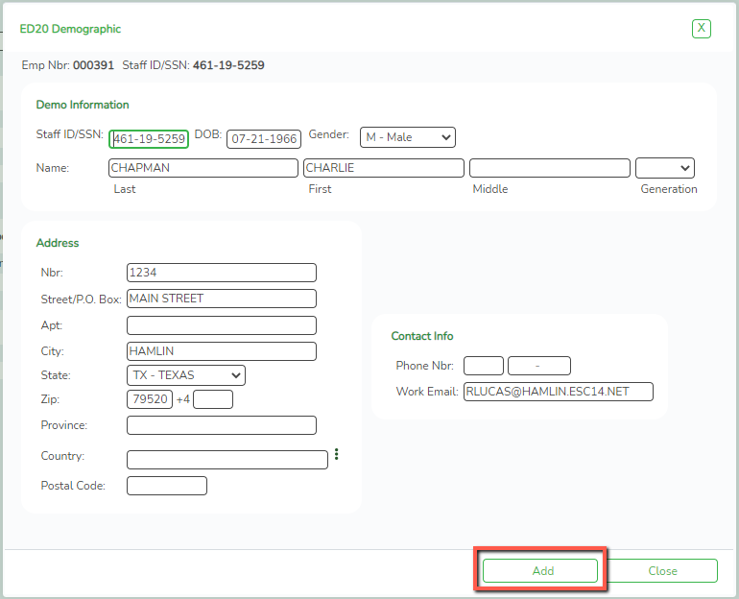Edit info as needed and click Add.

* + 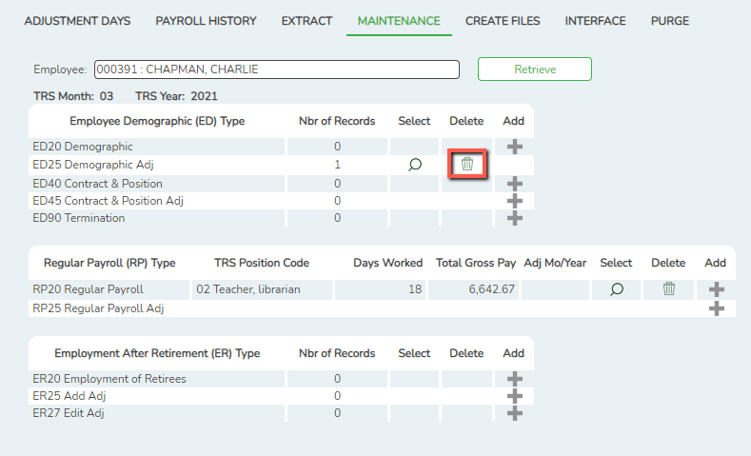Click the Trash Can icon to delete a record.
  + 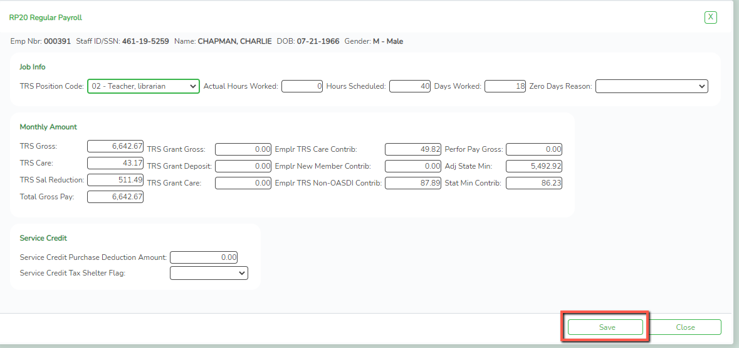Use the Spyglass icon to view existing data. Edit as needed and click Save.

1. **Create Files tab** – used to create files to send through the RE Portal. Note you may select to create all files at once or pick and choose as desired.
   * Select the box(es) to create one or more files. Note ellipsis buttons that allow for more detailed selections.
   * 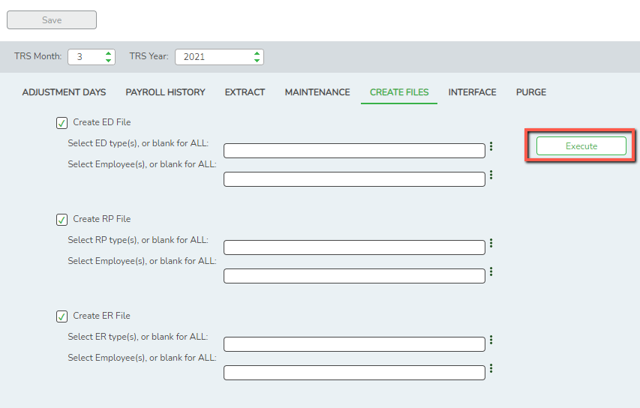Once selections are made, click **Execute**.

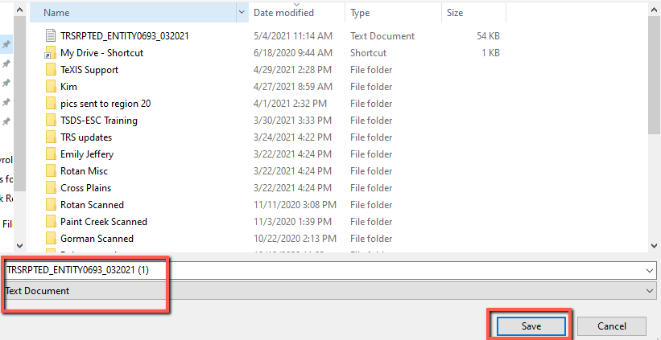You will be prompted to save each report. Save as usual so you can send through the RE Portal.

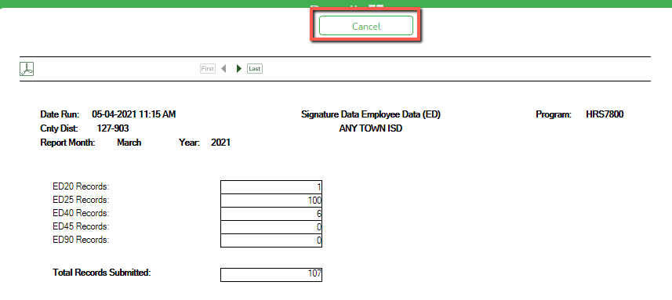Once all have saved, click the Cancel button to get the popup to go away.

1. **Interface tab** – used to interface RP. Many TRS Contributions are interfaced when you interface Payroll, however, the following are not interfaced until this step:
   * Stat Min
   * Public Education Employer Contribution
   * Child Nutrition amounts for TRS 3
   * Child Nutrition amounts for TRS 489

**NOTE: If you have a Payroll Clearing Account at the bank, these amounts will need to be transferred. Our Transfer Transaction Worksheet (available on our website) will display these amounts and document the amounts needed for transfer.**

* Choose the Accounting Period desired
* Select the file you wish to Interface
* Enter a Posting Date (many choose their Pay Date to keep entries related to payroll together in the General Ledger.)
* 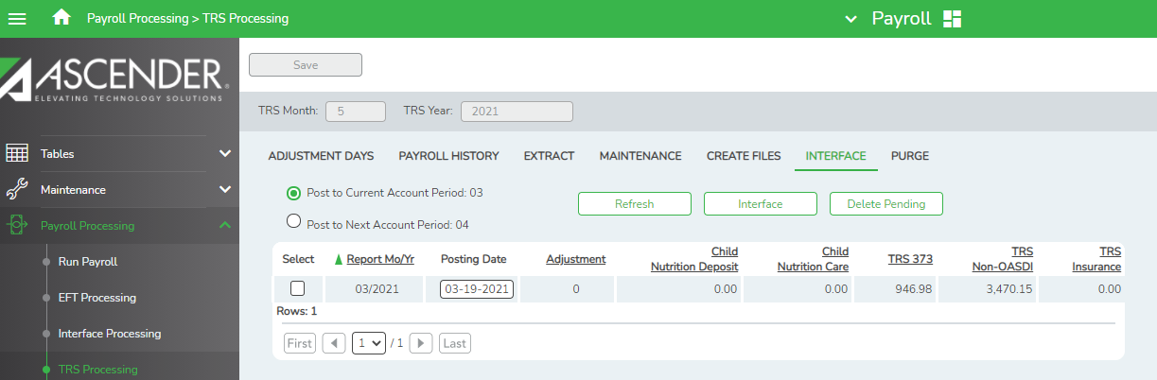Click Interface button

1. **Purge tab** – used to remove old files. This will likely be added to our End of Year documents. Please do not use this at this time.

**_____6. Submit ED file.** Log into the Reporting Portal on the TRS Website.

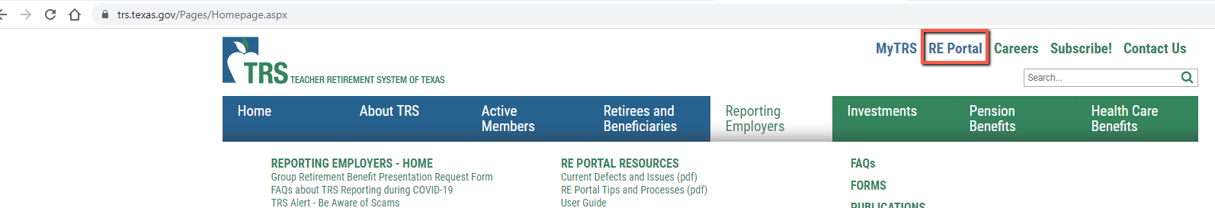

Choose the link to Create and Maintain Reports.

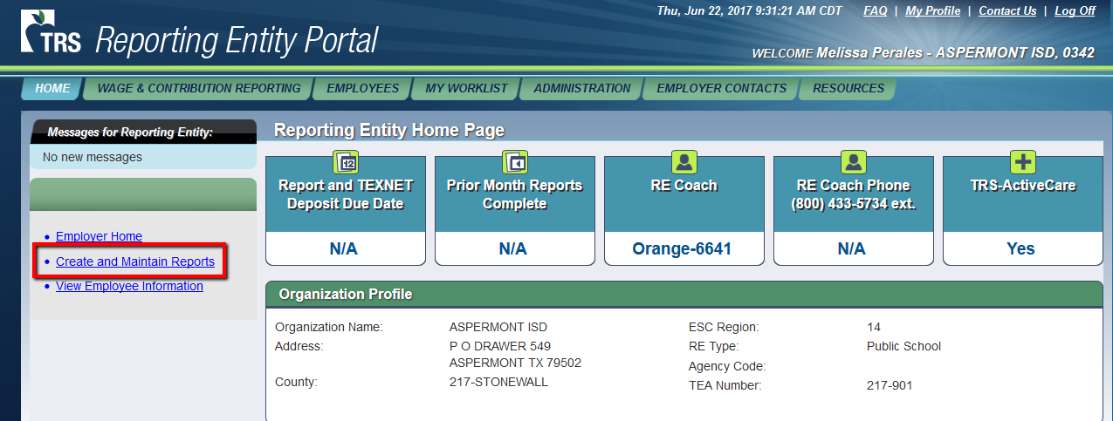

Click link to **Create New Report Detail**.

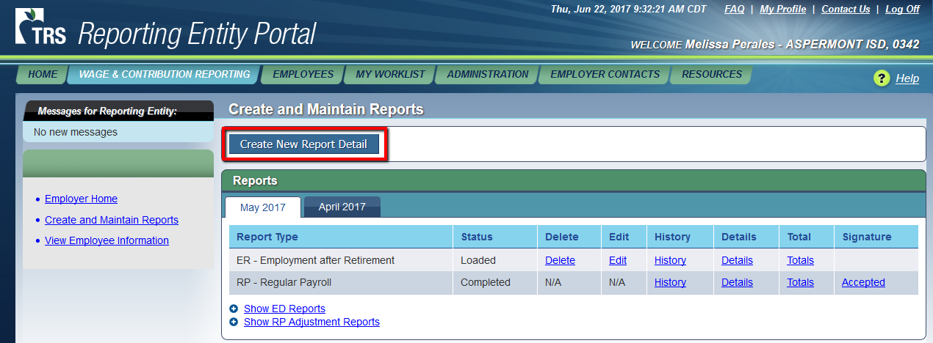

**Choose Report Type ED** – Employee Demographic and the applicable Report Month and Year. Select the radio button to **Upload Report** and click **Next.**

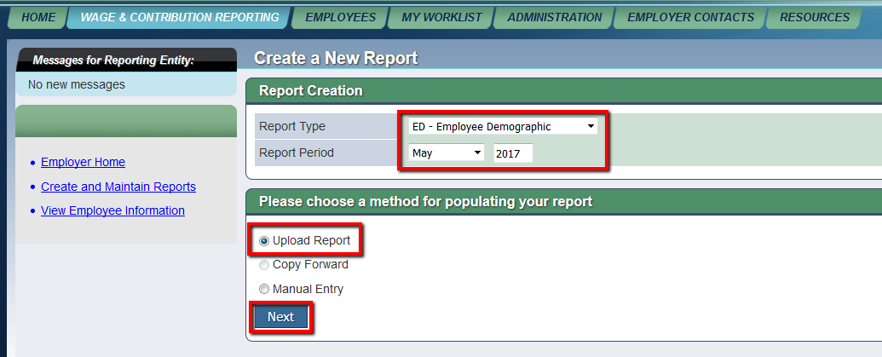

Browse to find your **ED text file.** Once the file is listed beside the **Browse** button, click **Upload**. The ED files are picked up every **half hour** for processing. You may check back periodically to see the status of the ED file.

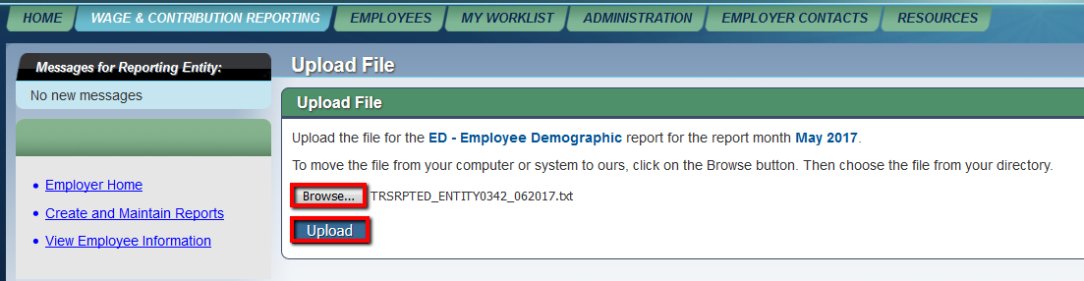

**It MUST reach Completed status at TRS before you can submit RP files.**

To check the status, click the Create and Maintain Reports link and then click to Show ED Reports.

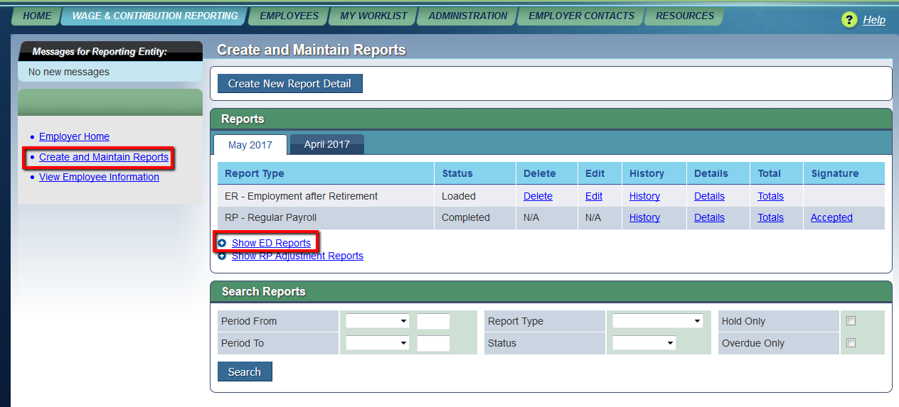

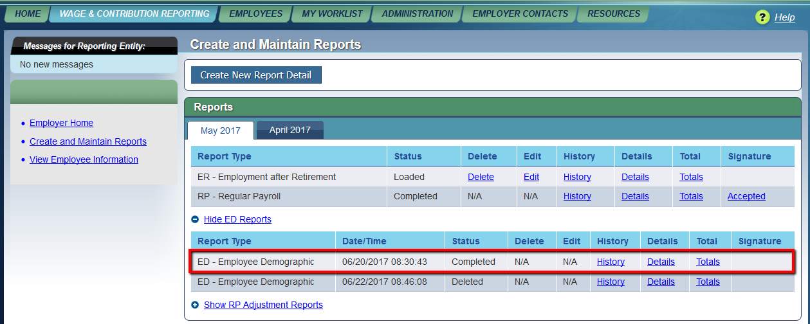

If the status shows **Rejected,** you will need to click the **Edit** button to view the details. You will be able to click on any record that is rejected, see the errors and **manually make corrections**. As the corrections are made, **Save** the changes at the bottom of the screen. When all **corrections have been made,** ***Submit all records*** at the bottom of the screen. Continue to check back until you see your ED records have reached a status of **Completed.**

DO NOT UPLOAD RP to the TRS RE Portal until ED COMPLETES

**_____7. Submit RP file.** Log into the Reporting Portal on the TRS Website. Choose the link to Create and Maintain Reports.



TEST ISD

123 MAIN

ABILENE, TX

123 – TEST

Click link to **Create New Report Detail.**



Choose Report Type RP – **Regular Payroll** and the applicable **Report Month and Year**. Select the radio button to **Upload Report** and click **Next**.

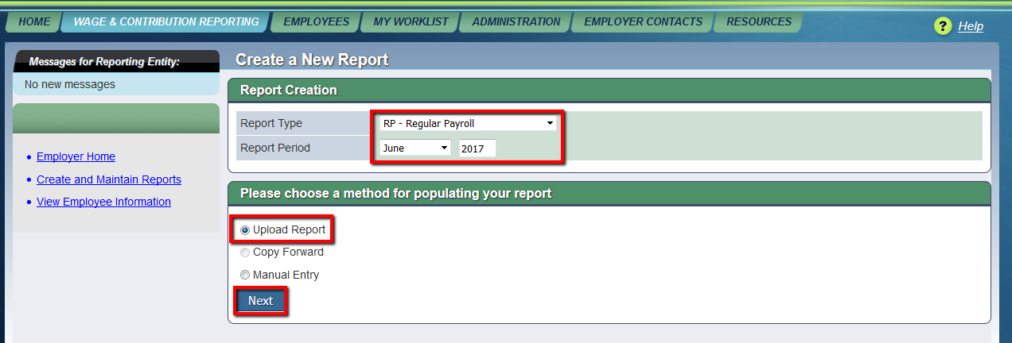

**Browse** to find your RP text file. Once the file is listed beside the Browse button, click **Upload**. The RP files are picked up every half hour for processing. You may check back periodically to see the status of the RP file.

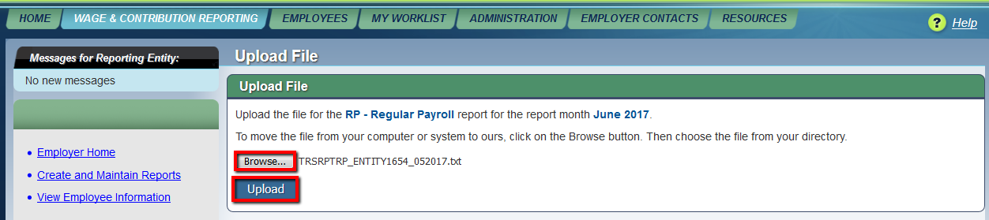

To check the status, click the **Create and Maintain Reports link**.

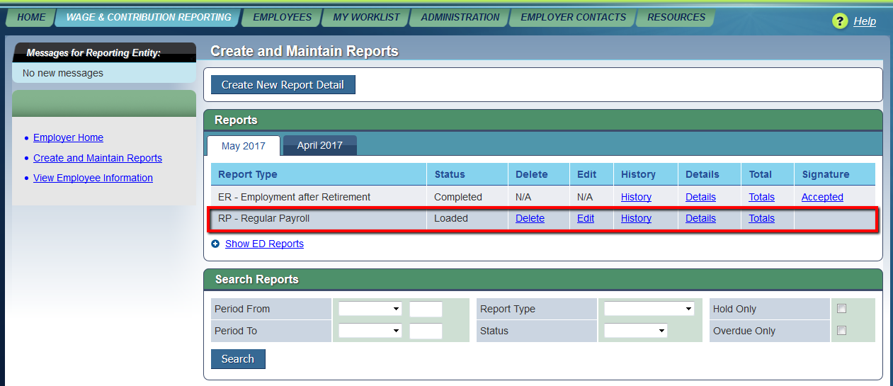

If the status shows **Rejected,** you will need **to click the Edit button to view the details**. You will be able to click on any record that is rejected, see the errors and manually make corrections. As the corrections are made, Save the changes at the bottom of the screen. **When all corrections have been made, Submit all records at the bottom of the screen.** Continue to check back until you see your RP records have reached a status of Pending, you are ready to submit your signature.

**Query TRS reports for Completed Status**. Return to the RE Portal and review the status of your TRS reports. When your report has a status of Pending, you can submit signatures.

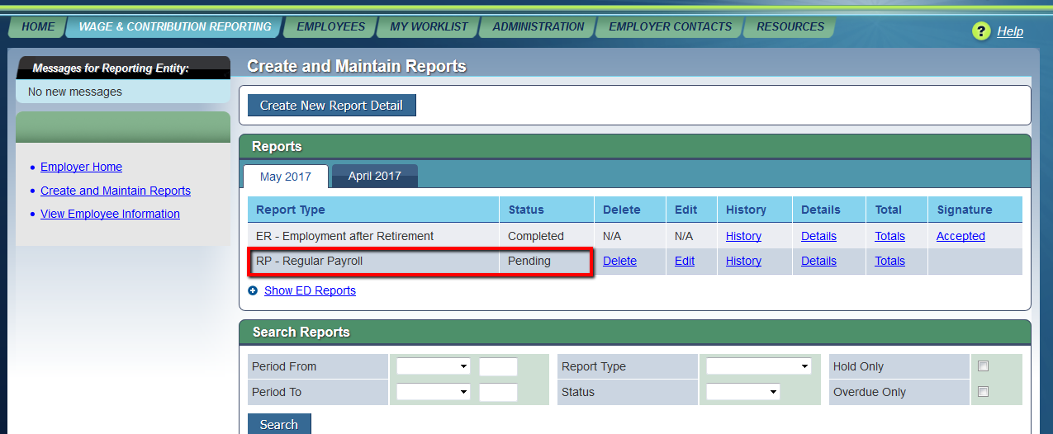

From **Wage and Contribution Reporting > Submit Signature**, submit signatures for your RP report.

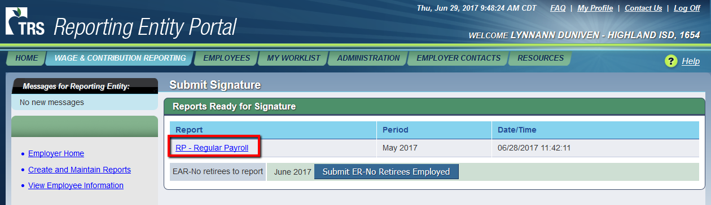

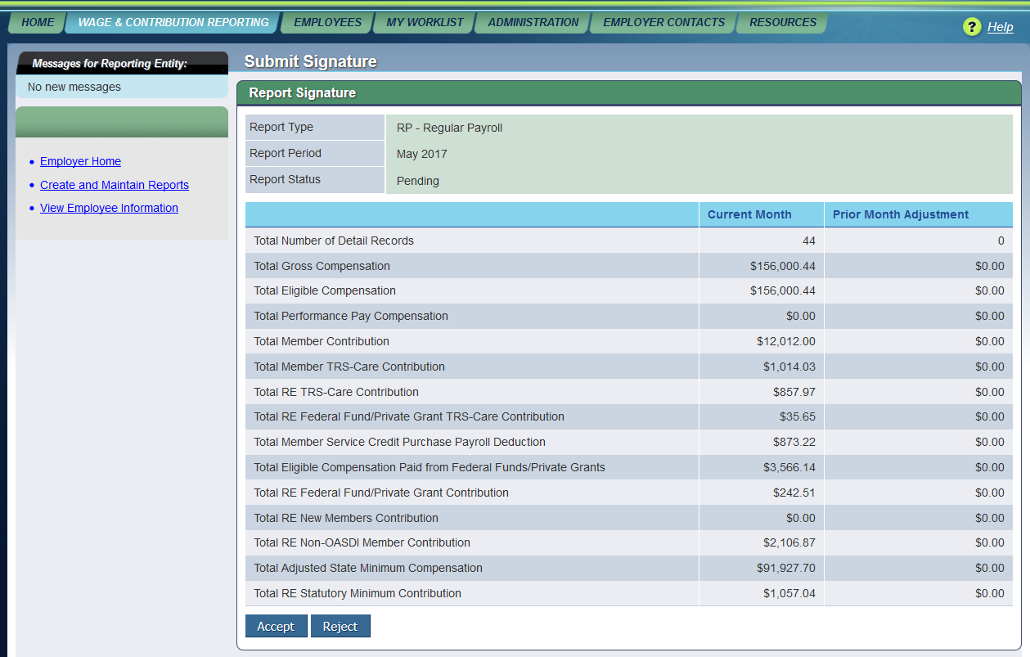

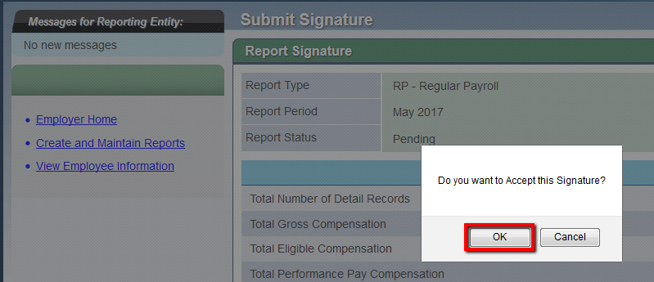

**NOTE: You should TexNet the contribution amounts shown on the signature at the RE Portal, using any credits you may have on your TRS Ledger. If the amounts on the signature differ from those displayed in your General Ledger Payroll Liability accounts in TxEIS, HR corrections and/or a manual JV may be needed to bring your books in balance. Please refer to our TRS adjustments and corrections spreadsheet on our website for help in making any corrections or adjustments.**

**_____8.** **Upload your ER file just as you did the ED & RP** – Employment after Retirement, correct any errors and submit your signature. If you have no retirees to report, simply submit a blank signature. **Wage & Contribution Reporting > Submit Signatures > Blank ER Signature**.

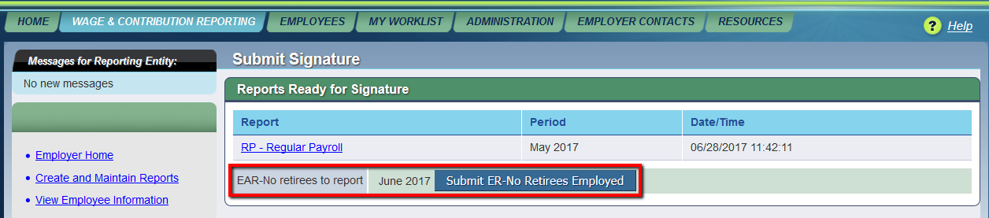

**_____9. Run the TRS On-Behalf Payment.** From **Reports> TRS Reports,** print or save the **TRS On-Behalf Journal (HRS4150).**

Input the following in the report parameters:

* From Pay Date: Current Pay Date (MMDDYYYY)
* To Pay Date: Current Pay Date (MMDDYYYY)
* Single Revenue Acct per Selected Fund: Y
* Interface Transaction Date: Current Pay Date (MMDDYYYY)
* Finance Accounting Period: as desired

Expenditure Account Code: Click ellipsis button to the right and create a mask such as 199-XX-6144-00-999-X99-000.

**Note: This should match the account code(s) used to Budget during the Next Year Payroll process.**

* Select a distribution error account code. Click the ellipsis button to the right and select an account such as 199-11-6144-00-999-X11-000.

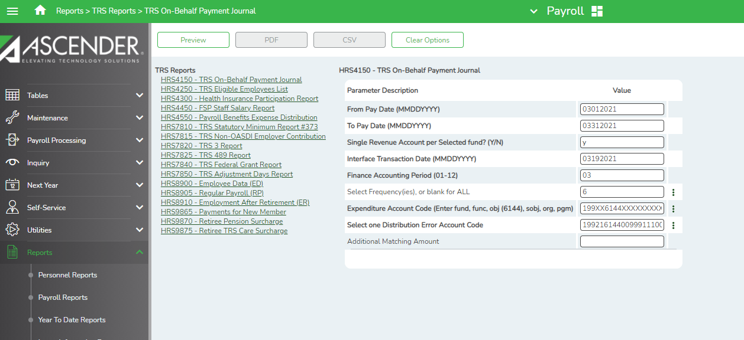

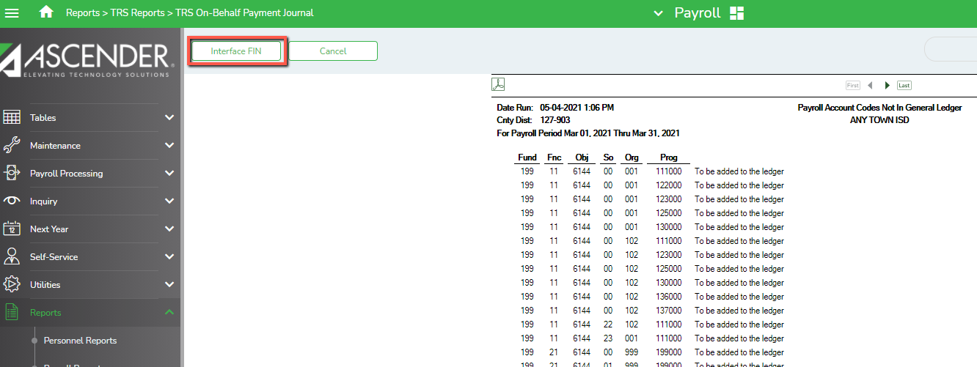**Interface to Finance** (button at the top left of screen)

**_____10. For districts with a Payroll Clearing Account at the bank, enter Stat Min Contribution total, and the Child Nutrition amounts for the TRS 3 and 489, and the Public Education Employer Contribution total on the Transfer Transaction worksheet OR below and transfer money at the bank if applicable.**

|  |  |
| --- | --- |
| TRS 373 Statutory Minimum | $ |
| TRS 3 (Child Nutrition Amount Only) | $ |
| TRS 489 (Child Nutrition Amount Only) | $ |
| Public Education Employer Contribution (was NON-OASDI) | $ |
| Total Transfer Amount | $ |

**_____11. Submit TEXNET online.** The electronic payment is due on or before the 6th of the following month. We recommend you wait until you are sure you have processed the last payroll for that month. The web address is: <https://texnet.cpa.texas.gov/> Use the following to help compile the numbers.



**Teacher Retirement System**

**Identification #: _______ Location #: _______**

|  |  |
| --- | --- |
| **Total Amount** | $ |
| **Settlement Date** |  |

|  |  |  |  |
| --- | --- | --- | --- |
| **RE Portal Description** | **TexNet Description** |  | **Payroll Clearing Accounts** |
| **Total Member Contribution** | **Member Contribution Amount** | **$** | **2155.00** |
| **Total Member TRS-Care Contribution** | **Member TRS-Care Contribution Amount** | **$** | **2155.00** |
| **Federal Funds/Private Grant Contribution** | **RE Federal Funds/Private Grant Contribution Amount** | **$** | **2155.01** |
| **Statutory Minimum Contribution** | **RE Statutory Minimum Contribution Amount** | **$** | **2155.02** |
| **N/A** | **Non-Education Contribution Amount - TRS 370** | **$** | **N/A** |
|  | **Interest Amount Due - TRS 376** | **$** |  |
| **Total Federal TRS-Care Contribution** | **RE Federal Fund/Private Grant TRS-Care Contribution Amount** | **$** | **2155.03** |
| **N/A** | **Education/General-Local Funds Amount Due - TRS 553** | **$** | **N/A** |
| **Total Service Credit Purchase Deduction** | **SSBB Deduction - TRS 565**  (This is TRS Buy Back) | **$** | **2159.00-XXX**  **(XXX = deduction codes)** |
| **Invoice (must enter total on bill even if not accurate)** | **TRS Active Care Billed Amount Due** | **$** | **2153.00-XXX**  **(XXX = deduction codes)** |
| **Total RE TRS-Care Contribution** | **RE TRS-Care Contribution Amount** | **$** | **2155.04** |
| **RE Payments for New Members Contribution** | **RE New Members Contribution Amount** | **$** | **2155.05** |
| **RE Pension Surcharge for Retirees** | **RE Pension Surcharge for Retirees** | **$** | **2155.06** |
| **RE TRS-Care Surcharge for Retirees** | **RE TRS-Care Surcharge for Retirees** | **$** | **2155.07** |
| **Public Education Employer Contribution** | **Public Education Employer Contribution (was Non-OASDI)** | **$** | **2155.08** |

**_____12. Post the TexNet wire transfer.** We recommend using a Transfer Transaction so it will show on your bank reconciliation screen, making bank rec easier. From **Utilities > Transfer Transaction Processing > Transaction Maintenance tab**, click **+Add** to enter data for this payroll. Enter the Pay Date and Vendor Name (TRS). Leave the Employee Number and Deduction Code columns blank. Enter the deduction amount and account codes indicated on the previous step. After entering, **Refresh Totals**, ensure transactions equal the total transfer and **Save**.

**Note: We recommend using amounts accepted by TRS. Use the Totals report or the Signature from the TRS RE Portal.**

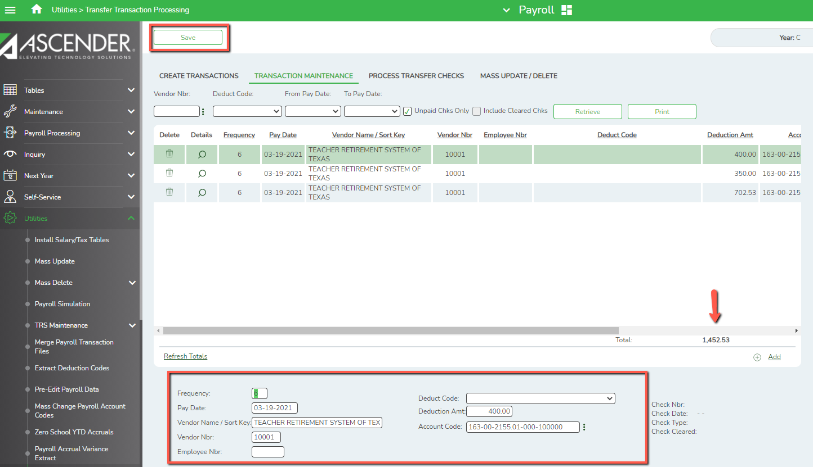

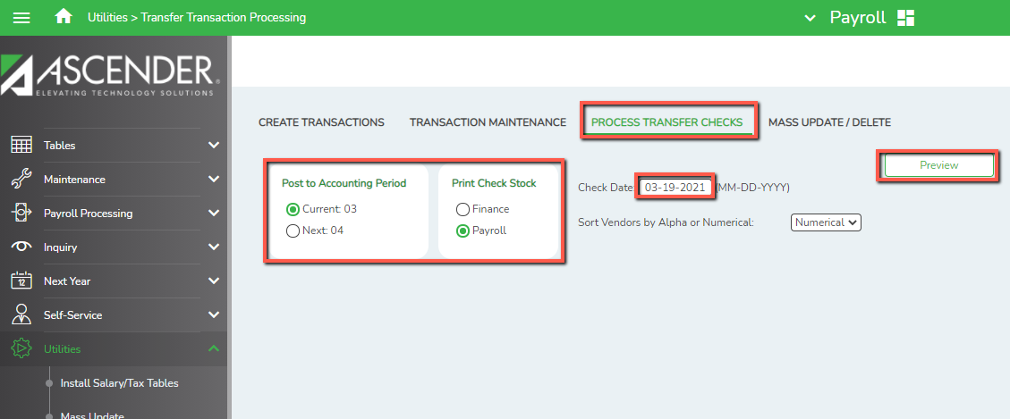On the **Process Transfer Checks** tab, select the appropriate accounting period, select Payroll check stock, enter the Pay Date as the Check Date and click **Preview**.

Assign a check number. (Recommend TRS MM where MM is the pay month.) Review for accuracy and select **Next**.

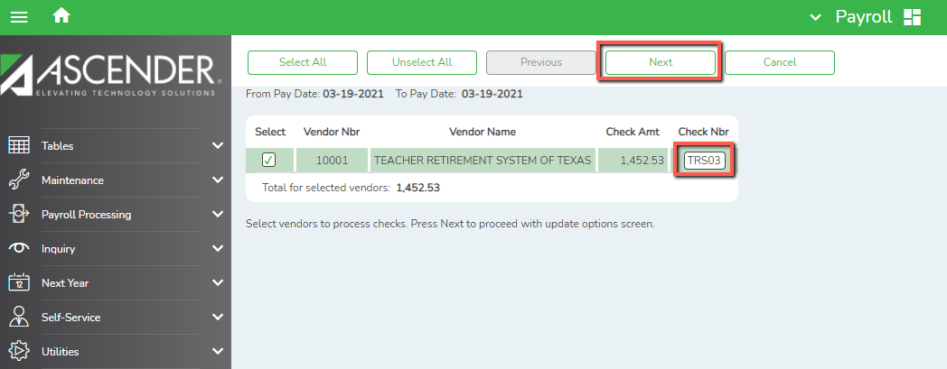

Check the top 2 boxes. Do **not** check to Print the Fund Transfer Summary as these amounts were included in your payroll transfer. Click **Update**.

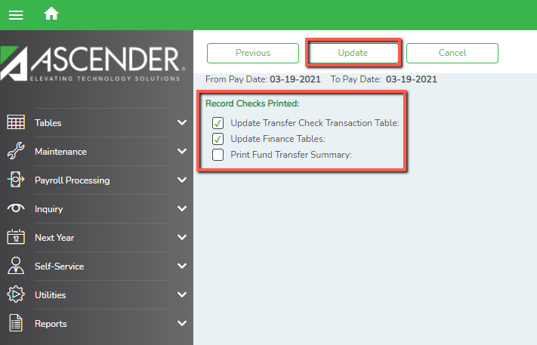

No check in Print Fund Transfer Summary box.

_____**13. Interface your TRS 3, TRS 489, TRS 373 (Stat Min) and Public Education Employer Contribution (was Non-OASDI).** If this process is not yet completed, please do so now. From **Payroll Processing>TRS Processing>Interface.** Use your pay date as the posting date and check the select button. Then choose the interface button to process.

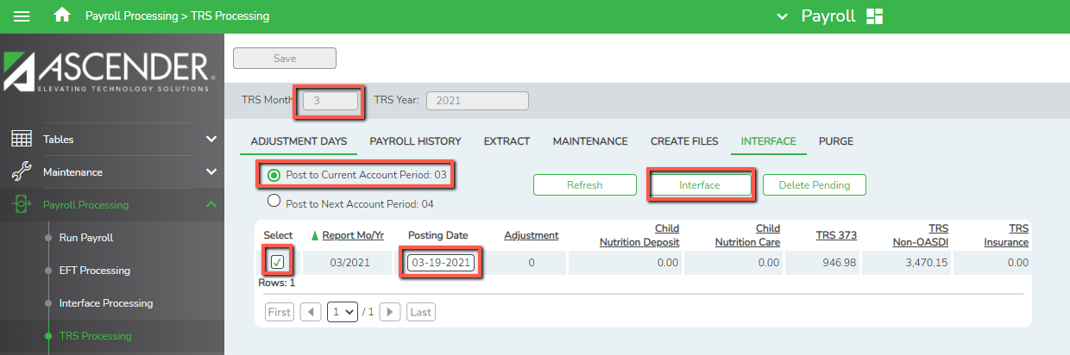

**_____14. Run the Payroll Accrual Variance Extract Utility and correct as needed.** From **Utilities > Payroll Accrual Variance Extract**, pull all employees to the right, select the latest pay date and Run.

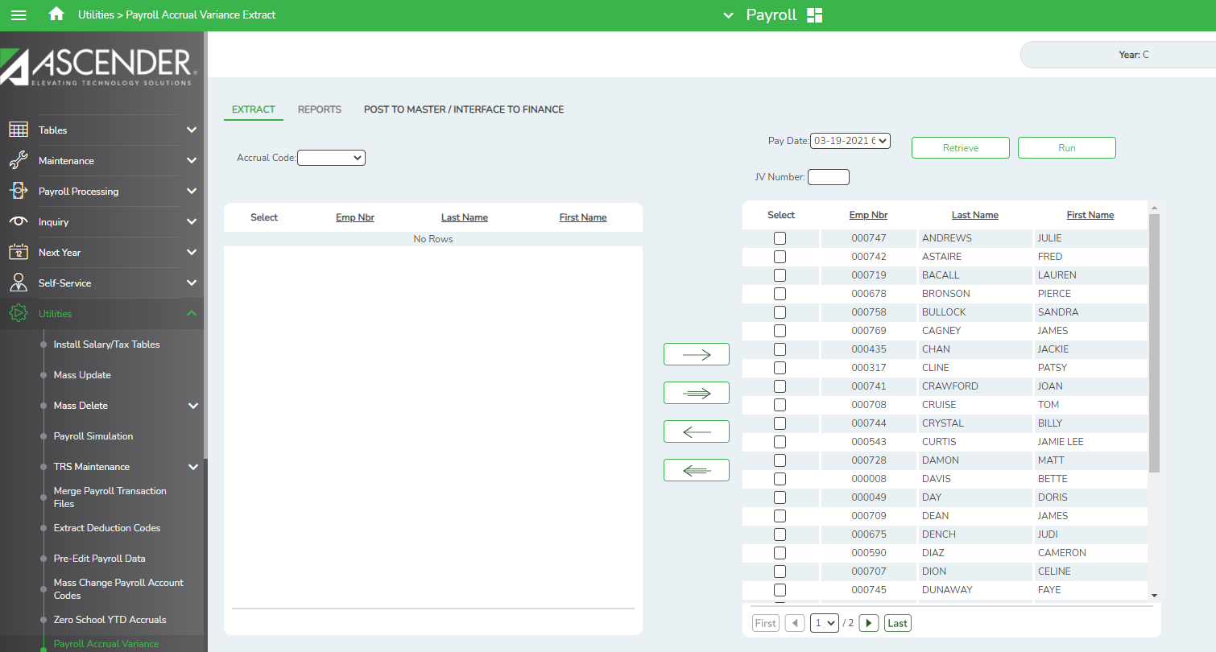

Verify all payrolls extracted correctly. Close the screen and proceed to the Reports tab.

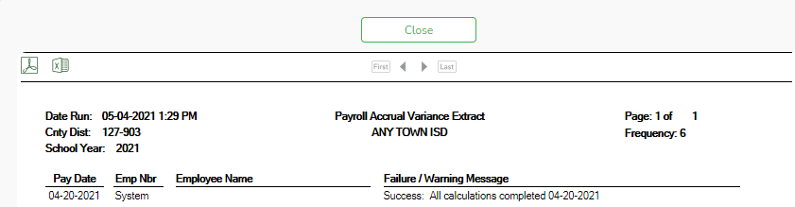

Generate the Payroll Accrual Variance Report by Name. You may leave the Minimum Variance at .00 to see all variances or change to .08 to leave off any employees whose variance is only due to rounding.

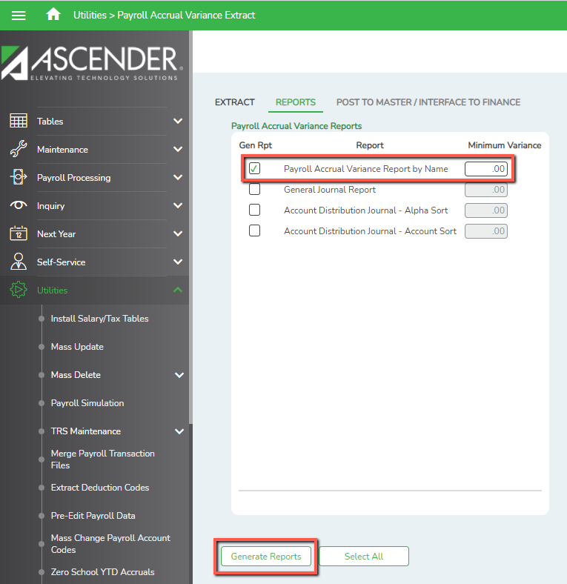

Analyze each employee’s variance to determine the cause. Once you have determined the cause, you’ll know if you need to simply make a correction to their screen, or if you need to post changes to the Master Payroll File and/or Interface those changes to Finance.

**_____15. If applicable, run the 941 Quarterly Tax Report.**

April 30 – 1st Quarter 941 due to IRS for January – March

July 31 – 2nd Quarter 941 due to IRS for April – June

October 31 – 3rd Quarter 941 due to IRS for July – September

January 31 – 4th Quarter 941 due to IRS for October - December

Access from **Payroll >** **Reports > Quarterly/Annual Reports > 941 Worksheet (HRS 5000).** The 941 report should be run for the three months of the quarter and compared to the tax deposits made through EFTPS for the same three months. The Quarterly 941 form due to the IRS can be found at: <http://www.irs.gov/pub/irs-pdf/f941.pdf>.

**_____16. If applicable, run the TWC Wage List for the Texas Workforce Commission.**

April 25 – 1st Quarter 941 due to TASB for January – March

July 25 – 2nd Quarter 941 due to TASB for April – June

October 25 – 3rd Quarter 941 due to TASB for July – September

January 25 – 4th Quarter 941 due to TASB for October – December

Access from **Payroll >** **Reports > Quarterly/Annual Reports > TWC Wage List (HRS 5050).** The report will create an electronic file. Save in the TWC folder in the monthly payroll folder. You will need the following information to complete the parameters of the reports which can be obtained from TASB if needed:

* + - Tax Area Number
    - Tax Rate
    - County Code with greatest number of employees

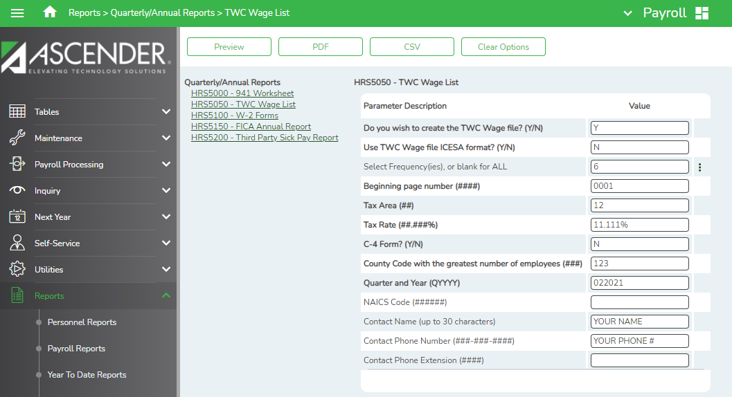

Tax The following can be obtained from your unemployment insurance carrier: Tax Area, Tax Rate and County Code with the greatest number of Employees

**_____17. Run Unique ID’s and make sure any name changes are included in the upload to TSDS. Personnel > Utilities > Texas Unique Staff ID interface**

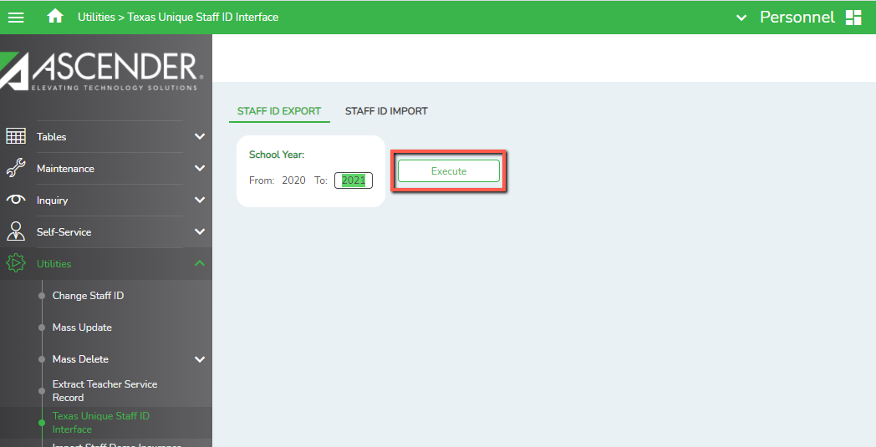

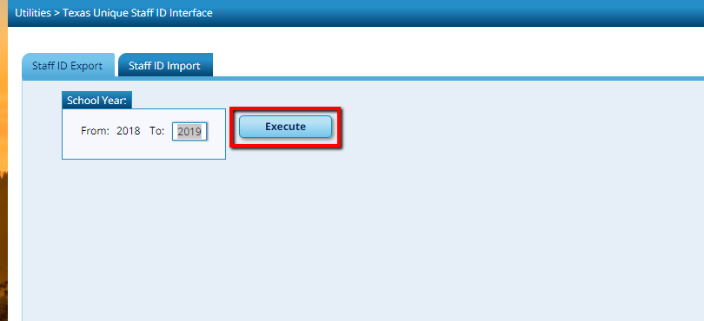

**_____18. Reconcile Payroll Clearing Liability Accounts.** From **Finance > Inquiry > General Ledger Inquiry > General Ledger Account Summary tab**, enter your payroll clearing fund and 2XXX in the object field. **Retrieve**.

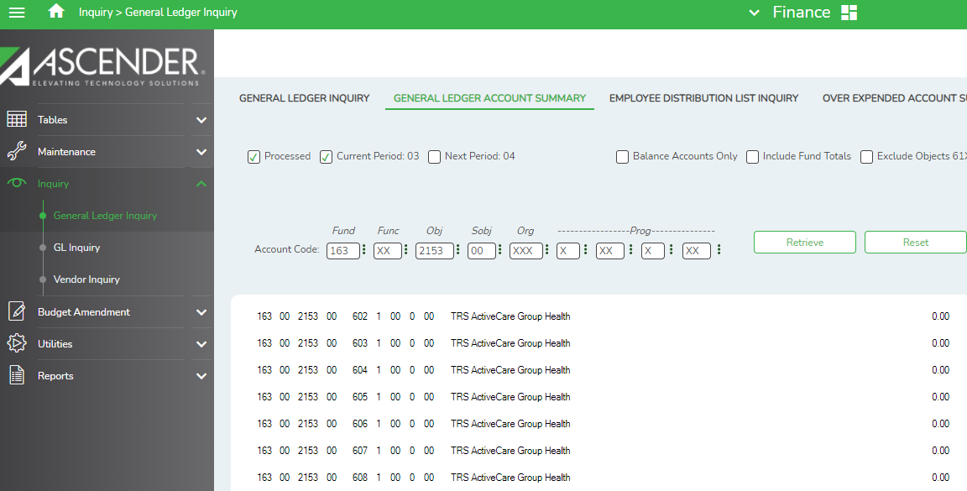

If these accounts are not zeroes, identify the differences. Some may be legitimate; such as amounts for TRS Active Care bills that don’t match employee deductions due to a new employee or one that recently left the district. Others may not be correct. Make JVs or changes in HR as needed to clear accounts.

Also, go to the TRS portal and reconcile to your RE Ledger Balance.

